**DOCUMENT USER GUIDE AND INSTALL**

**SYSTEM MANAGEMENT CERTIFICATE**

**MODULE**

**1.** **Introduction** 2

1.1 ABC Center Certificate. 2

1.2 Member of group two. 2

**2.** **Install Database.** 3

2.1 Overview database. 3

2.2 Setup User login with TCP/IP SQL Server. 3

2.3 Create Database 11

**3.** **Install Software Certificate:** 15

**4.** **How to Management System** 21

4.1 Management Users 21

4.2 Management Student 23

4.3 Management Register of Student 32

4.4 Management Certificate 42

4.5 Management Subjects 49

4.6 Management Exam Mark 54

4.7 Management Certificate Store. 58

4.8 Management User 62

4.9 Management Course 66

4.10 Student Result. 70

4.11 Student Fail. 72

4.12 Change Password 75

4.13 Print Certificate. 77

1. **Introduction**
   1. ABC Center Certificate.

The ABC Center Certificate is a center works for the "ABC" institute to developing the certification system for the students who have completed the exam. For each student who go to the “ABC” institute for register.

This Center have a lot of certificate. For example: English Certificate include A, B, C, and TOIEC…

ABC Center Certificate main missions is providing regular contests for students. Students can registration at ministry room but before that student can find out about the information the certificate, they want to registry like Certificate ID, all subject they must pass to receive the certificate. After learning about information, the student receives studentID this ID will be confidential, so it won’t be exposed to protect information of student. But if student ID have been lost or delete it still can recuperate because all the information always saves on the database of center.

* 1. Member of group two.

|  |  |  |
| --- | --- | --- |
| **Members** | **Role and Responsibilities** | **Contact** |
| Nghi Dang Quang | **Leader/ Analyst/ Designer/ Developer/Tester/ Implementation** | **dqnghia18086@cusc.ctu.edu.vn** |
| Khanh Nguyen Le | **Analyst/Implementation/**  **Developer/ Tester** | **nlkhanha18083@cusc.ctu.edu.vn** |
| Thang To Toan | **Analyst/Designer/**  **Developer/ Tester** | **ttthanga18075@cusc.ctu.edu.vn** |
| Thanh  Nguyen Phuoc | **Analyst/Implementation**/ **Developer/ Tester** | **npthanha18141@cusc.ctu.edu.vn** |

1. **Install Database.**
   1. Overview database.

Database is collection of interrelated data where data can be easily accesses, managed and updated. For example, consider ABC institute maintains details of the student such as name of the student, age, address, class etc. These all records are related with student stored in a database.

Database management System is collection of data and set of programs to access the data. It allows creation, definition and manipulation of database. DBMS provides protection and security to database. Some examples for popular DBMS are MySQL, Oracle, Sybase, Microsoft Access and IBM DB2. But this System just run only on SQL Server.

* 1. Setup User login with TCP/IP SQL Server.
     1. Reset SQL password
* Step 1: Login into SQL Server

Figure 2.1: Login Sql Server

* A screenshot of a cell phone

  Description automatically generatedStep 2: In Object Explorer, open Security folder and open Logins folder. Right click on SA account and go to Properties.

Figure 2.2: Properties account SA

* A screenshot of a social media post

  Description automatically generatedStep 3: Change SA password and confirm it. Click OK.

Figure 2.3: Change password SQL server

* + 1. Config SQL server
* Step 1: On Start menu click mouse right choose Computer Management

Figure 2.1: Choose Computer Management

* Step 2: In the interface of computer management select Server and Application.

After selecting Server and Application continue select SQL Server activate.

Figure 2.2: Back group of Computer Management

Figure 2.3: Configuration SQL Server Services

* Step 3: In Service and Applications select Protocol for MSSQLSERVER

Figure 2.4: Configuration TCP/IP

Select Protocol and continue choose “Yes”.

After Click the button “APPLY” and finally click the button “OK”.

Figure 2.5: Configuration of Properties Protocol

Select IP Address and continue choose “Yes” (Same Figure 2.6).

Figure 2.6: Configuration of Properties IP Address

* + 1. Create User SQL Login
* Step1: On Start menu select Microsoft SQL Server Management

Figure 2.7: Select Microsoft SQL Server Management

* Step 2: Display form connect to server.

Enter login and password continue click the button “CONNECT” (same figure 2.8).

After connecting to server successful display back group of SQL Server (same figure 2.9).

Figure 2.8: Connect to SQL Server

Figure 2.9: Back group of SQL Server

* 1. 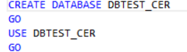Create Database

Figure 2.10: Example code create database

* + 1. 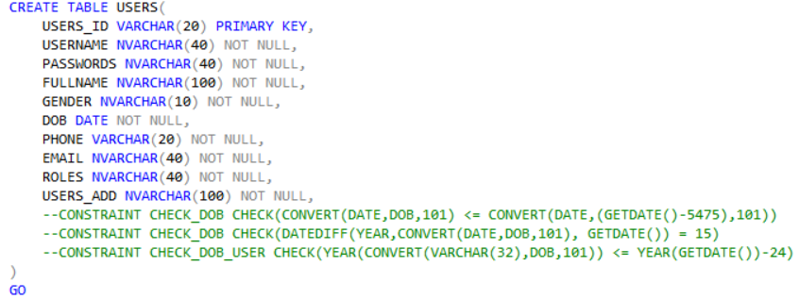Create Table, Constant

Figure 2.11: Example code create table, constant

* + 1. 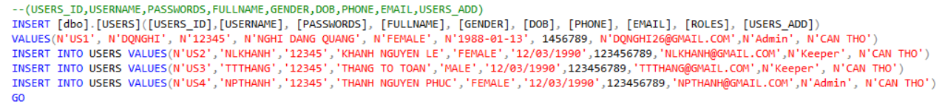Insert Table

Figure 2.12: Example code insert table

* + 1. 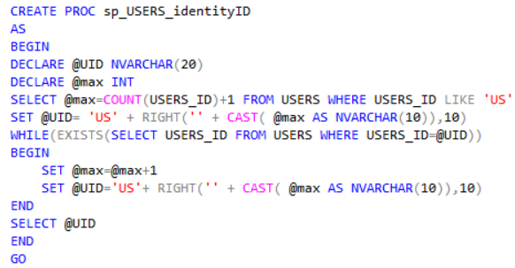Create PROC

Figure 2.13: Example code create PROC

* + 1. Update Table, Column

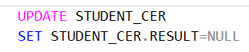

Figure 2.14: Example code update table, column

* + 1. Delete Table, Column



Figure 2.15: Example code delete table, column

* Open files 

And then CTRL + A and press key F5 or choose 

* Restore a database on SQL Server using *.mdf, *.ldf and *.ndf files.

**Using Enterprise Manager**:

* Expand the registered SQL server
* Right-click Databases, select All Tasks -> Attach Database...
* Click the "..." button to browse for the *.mdf file
* Highlight the necessary *.mdf file and click OK
* Click OK again
* The database will now show up in Enterprise Manager

OR

* detach the database (right click the database and click Detach)
* copy the *.mdf and *.ldf files to your backup location
* attach the database (right click Databases and click Attach)

**This is the path where you will find MDF file:**

C:\Program Files\Microsoft SQL Server\MSSQL13.SQLEXPRESS\MSSQL\DATA

* Backup database
* Open SQL Server Management Studio Express and connect to the SQL server.
* Expand **Databases**.
* Right-click on the database you want to back up, then select **Tasks > Back up**. (This is not available for version 2018/2019)
* On the Back up Database window, make sure the **Database**field contains the name of the database you want to back up.
* Select the **Backup Type**. By default, it is **Full**- leave it set to that.
* Click **Remove**to remove the default/last backup file name.
* Click **Add**to open the Select Backup Destination window.
* Click **[...]**next to the File Name field.
* On the Locate Database Files window, select the folder where you want to backup file to go. By default, it is **...\Microsoft SQL Server\MSSQL.1\MSSQL\Backup**.
* In the **File Name** field, type the name for this backup, with a \***.bak**extension. For example, **xyz_20080221.bak** for a backup of the XYZ database created on 21 February 2008.
* Click **OK** to close the Locate Database Files window.
* Click **OK** to close the Select Backup Destination window.
* Click **OK**to start the backup. The progress icon displays in the lower left corner, and a ‘completed successfully’ message displays when it’s done.

1. **Install Software Certificate:**

* **A screenshot of a cell phone

  Description automatically generatedStep 1: Download file setup**

Figure 3.1: Click on file “Cer_Manager_Setup”

* **Step 2: Install file setup.**

Figure 3.2: Step 1 of install the setup and click the button “Next”

**

Figure 3.4: Click the button “Next”

Figure 3.3: Click the button “Install”

Figure 3.4: Click the button “Next”

Figure 3.5: The finish install setup

* **Step 3: Open the saved folder during installation**

Figure 3.6: Click the folder

Figure 3.7: On folder “Cer_Manager” . Next click the folder “dist”

Figure 3.8: On the folder “dist” . Click on the file “Cer.Manager” and Run application

1. **How to Management System**
   1. Management Users

* A screenshot of a cell phone

  Description automatically generatedA screenshot of a cell phone

  Description automatically generatedStep 1: Login connection with Database.

Figure 4.2: Form connect to database success

Figure 4.1: Form connect to Database

Step 2: Login username and password

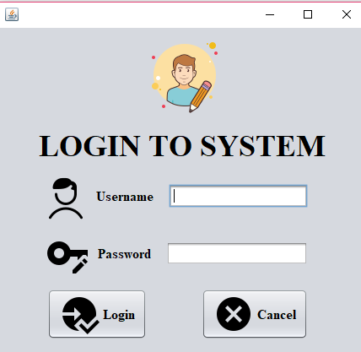

Figure 4.3: Form login to system

* A screenshot of a cell phone

  Description automatically generatedStep 3: Form system management certificate.

Figure 4.4: Form main of system management certificate

* 1. Management Student
* A screenshot of a cell phone

  Description automatically generatedStep 1: In form system management certificate. Click the button “Management Student”

Figure 4.5: Click the button “Management Student”

* Step 2: Display Form Management Student

Figure 4.6: Back group form “Management”

* A screenshot of a cell phone

  Description automatically generatedStep 3: User want add information student

Figure 4.7: Click the button “Add” in Management Student

After clicking the button “Add”. Enter information student and clicking the button “Save”. Information display in the table.

Figure 4.8: After clicking the button “Add”

Step 4: User want edit information student

Figure 4.9: Click the button “Edit” in Management Student

After clicking the button “Edit”. Enter information student want to edit and clicking the button “Save”. And display notify.

Figure 4.10: After clicking the button “Edit” in Management Student

* A screenshot of a cell phone

  Description automatically generatedStep 5: User want delete information student.

Figure 4.11: Click the button “Delete” in management student

After clicking the button “Delete”. Display message.

Click the button “OK” in message.

Figure 4.12: After clicking the button “Delete” in management student

Step 6: User want report information student.

Figure 4.13: Clicking the button “Report” in management student

After clicking the button “Delete”. Display form report. Choose folder save, enter name. And click the button “Save”

Figure 4.14: Report file

* Step 7: User want close form.

Click the button “Close” and back to form management main.

Figure 4.16: Back to form System Management Certificate

Figure 4.15: Click the button “Close” in management student

* 1. Management Register of Student
* 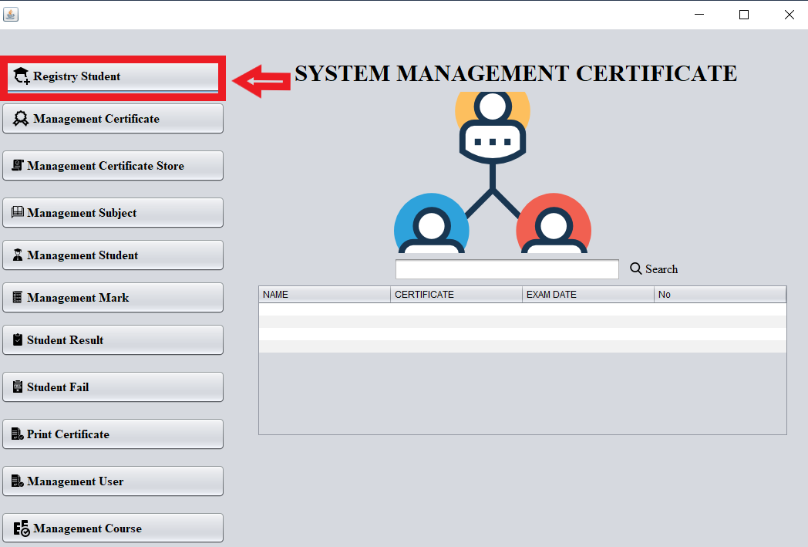Step 1: In form system management certificate. Click the button “Management Register Student”.

Figure 4.17: Click the button “Registry student”

* 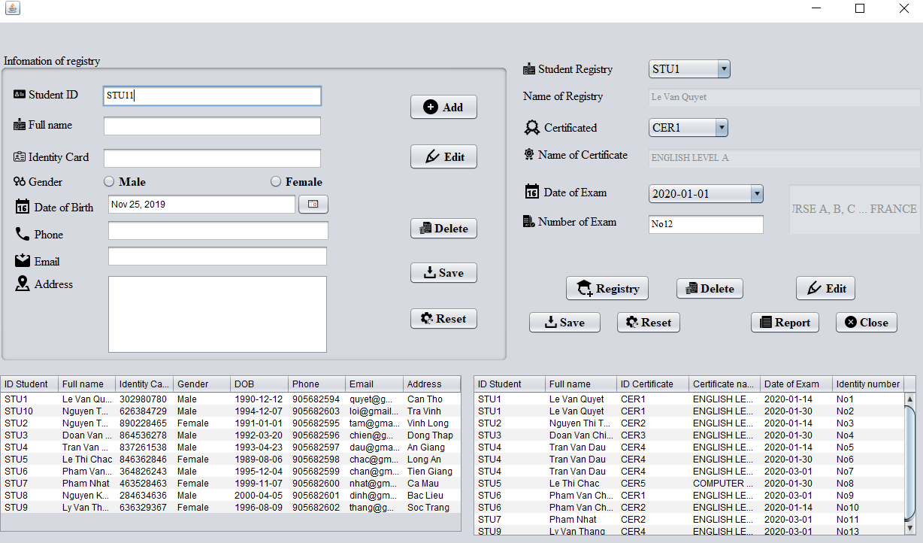Step 2: Display form Register Student.

Figure 4.18: Form Register Student

* A screenshot of a computer

  Description automatically generatedStep 3: User want add information student

Figure 4.19: Click the button “Add” in registry student

After clicking the button “add”. Enter information student and click the button “save”. (THE SAME STEP 3 – 4.2)

* A screenshot of a computer

  Description automatically generatedStep 4: User want edit information student

Figure 4.20: Click the button “Edit” in registry student

After clicking the button “Edit” and choose information student and enter information student be edit and click the button “Save”. (THE SAME STEP 4 - 4.2)

* A screenshot of a computer

  Description automatically generatedStep 5: User want delete information student

Figure 4.21: Click the button “Delete” in registry student

After clicking the button “Delete” and choose information student. Display message and click “OK”. (THE SAME STEP 5 -4.2).

* Step 6: User want report information student

After clicking the button “Report”. Display form report. Choose folder save, enter name. And click the button “Save”. (THE SAME STEP 6 – 4.2).

Figure 4.22: Click the button “Report” in registry student

* Step 7: User want register for student.

After clicking the button “Registry”. And choose to combo box “Student Registry”, “Certificated” and “Date of Exam”. And click the button “Save”.

Figure 4.23: Click the button “Registry” in registry student

Figure 4.24: After click the button “registry” in registry student

* A screenshot of a computer

  Description automatically generatedStep 8: User want edit information register for student.

Figure 4.25: Click the button “Edit” in registry student

* A screenshot of a computer

  Description automatically generatedStep 9: User want delete information register for student. After clicking the button “Delete” and choose information student want to delete to table. And display message, click the button “OK”.

Figure 4.26: Click the button “Delete” in registry student

* Step 10: User want report information register for student. (THE SAME STEP 6 – 4.2).

Figure 4.27: Click the button “Report” in registry student

* A screenshot of a computer

  Description automatically generatedStep 11: User want close form. (THE SAME STEP 7 – 4.2).

Figure 4.28: Click the button “Close” in registry student

* 1. Management Certificate
* A screenshot of a cell phone

  Description automatically generatedStep 1: In form system management certificate. Click the button “Management Certificate”.

Figure 4.29: Click the button “Management Certificate”

* A screenshot of a cell phone

  Description automatically generatedStep 2: Display Form Management Certificate.

Figure 4.30: Form Management certificate

* A screenshot of a cell phone

  Description automatically generatedStep 3: User want to add certificate. (THE SAME STEP 3 -4.2).

Figure 4.31: Click the button “Add” in management certificate

* A screenshot of a cell phone

  Description automatically generatedStep 4: User want edit certificate. (THE SAME STEP 4 -4.2).

Figure 4.32: Click the button “Edit” in management certificate

* A screenshot of a cell phone

  Description automatically generatedStep 5: User want to delete certificate. (THE SAME STEP 5 -4.2).

Figure 4.33: Click the button “Delete” in management certificate

* A screenshot of a cell phone

  Description automatically generatedStep 6: User want report certificate. (THE SAME STEP 6 -4.2).

Figure 4.34: Click the button “Report” in management certificate

* A screenshot of a cell phone

  Description automatically generatedStep 7: User want close form. (THE SAME STEP 7-4.2).

Figure 4.35: Click the button “Close” in management certificate

* 1. Management Subjects
* A screenshot of a cell phone

  Description automatically generatedStep 1: In form system management certificate. Click the button “Management Subject”.

Figure 4.36: Click the button “Management Subject”

* A screenshot of a cell phone

  Description automatically generatedStep 2: Display Form Management Subject.

Figure 4.37: Form Management subject

* Step 3: User want to add subject. (THE SAME STEP 3 – 4.2).

Figure 4.38: Click the button “Add” in management subject

* A screenshot of a social media post

  Description automatically generatedStep 4: User want edit subject. (THE SAME STEP 4 – 4.2).

Figure 4.39: Click the button “Edit” in management subject

* A screenshot of a social media post

  Description automatically generatedStep 5: User want to delete subject. (THE SAME STEP 5 – 4.2)

Figure 4.40: Click the button “Delete” in management subject

* A screenshot of a social media post

  Description automatically generatedStep 6: User want report subject. (THE SAME STEP 6 – 4.2).

Figure 4.41: Click the button “Report” in management subject

* A screenshot of a social media post

  Description automatically generatedStep 7: User want close form. (THE SAME STEP 7 – 4.2).

Figure 4.42: Click the button “Close” in management subject

* 1. Management Exam Mark
* A screenshot of a cell phone

  Description automatically generatedStep 1: In form system management certificate. Click the button “Management Mark”.

Figure 4.43: Click the button “Management Mark”

* A screenshot of a cell phone

  Description automatically generatedStep 2: Display Form “Management Mark”.

Figure 4.44: Form Management Mark

* A screenshot of a cell phone

  Description automatically generatedStep 3: User want add mark (THE SAME STEP 3 – 4.2).

Figure 4.45: Click the button “Add” in management mark

Step 4: User want edit mark (THE SAME STEP 4 – 4.2).

Figure 4.46: Click the button “Edit” in management mark

Step 5: User want delete mark (THE SAME STEP 5 – 4.2)

Figure 4.47: Click the button “Delete” in management mark

Step 6: User want report mark (THE SAME STEP 6 – 4.2).

Figure 4.48: Click the button “Report” in management mark

Step 7: User want close form (THE SAME STEP 7 – 4.2).

Figure 4.49: Click the button “close” in management mark

* 1. Management Certificate Store.
* A screenshot of a cell phone

  Description automatically generatedStep 1: In form system management certificate. Click the button “Management Certificate Store”.

Figure 4.50: Click the button “Management Certificate Store”

* A screenshot of a social media post

  Description automatically generatedStep 2: Display form Management Certificate Store.

Figure 4.51: Form Management Certificate Store

* A screenshot of a social media post

  Description automatically generatedStep 3: User want add Certificate Store (THE SAME STEP 3 – 4.2).

Figure 4.52: Click the button “add” in Management Certificate Store

* A screenshot of a social media post

  Description automatically generatedStep 4: User want edit Certificate Store (THE SAME STEP 4 – 4.2).

Figure 4.53: Click the button “edit” in Management Certificate Store

* Step 5: User want delete Certificate Store (THE SAME STEP 5 – 4.2).

Figure 4.54: Click the button “delete” in Management Certificate Store

* A screenshot of a social media post

  Description automatically generatedStep 6: User want report Certificate Store (THE SAME STEP 6 – 4.2).

Figure 4.55: Click the button “report” in Management Certificate Store

* A screenshot of a social media post

  Description automatically generatedStep 7: User want close form (THE SAME STEP 3 – 4.2).

Figure 4.56: Click the button “add” in Management Certificate Store

* 1. Management User
     + A screenshot of a cell phone

       Description automatically generatedStep 1: In form system management certificate. Click the button “Management User”.

Figure 4.57: Click the button “Management User”

* + - A screenshot of a social media post

      Description automatically generatedStep 2: Display form Management User.

Figure 4.58: Form Management User

* + - A screenshot of a social media post

      Description automatically generatedStep 3: User want add information user (THE SAME STEP 3 – 4.2).

Figure 4.59: Click the button “add” in Management User

* + - A screenshot of a social media post

      Description automatically generatedStep 4: User want edit information user (THE SAME STEP 4 – 4.2).

Figure 4.60: Click the button “edit” in Management User

* + - Step 5: User want delete information user (THE SAME STEP 5 – 4.2).

Figure 4.61: Click the button “delete” in Management User

* + - A screenshot of a social media post

      Description automatically generatedStep 6: User want close form (THE SAME STEP 7 – 4.2).

Figure 4.62: Click the button “add” in Management User

* 1. Management Course
* A screenshot of a cell phone

  Description automatically generatedStep 1: In form system management certificate. Click the button “Management Course”.

Figure 4.63: Click the button “Management Course”

* Step 2: Display form Management Course.

Figure 4.64: Form Management Course

* A screenshot of a social media post

  Description automatically generatedStep 3: User want add information course (THE SAME STEP 3 – 4.2).

Figure 4.65: Click the button “add” in Management Course

* A screenshot of a social media post

  Description automatically generatedStep 4: User want edit information course (THE SAME STEP 4 – 4.2).

Figure 4.66: Click the button “edit” in Management Course

* A screenshot of a social media post

  Description automatically generatedStep 5: User want delete information course (THE SAME STEP 5 – 4.2).

Figure 4.67: Click the button “delete” in Management Course

* A screenshot of a cell phone

  Description automatically generatedStep 6: User want report information course (THE SAME STEP 6 – 4.2).

Figure 4.68: Click the button “report” in Management Course

* Step 7: User want close form (THE SAME STEP 3 – 4.2).

Figure 4.69: Click the button “close” in Management Course

* 1. Student Result.
* A screenshot of a cell phone

  Description automatically generatedStep 1: In form system management certificate. Click the button “Student Result”.

Figure 4.70: Click the button “Student Result”

* A screenshot of a cell phone

  Description automatically generatedStep 2: Display form Student Result

Figure 4.71: Form Student Result

* A screenshot of a cell phone

  Description automatically generatedStep 3: User want report Student Result

Figure 4.72: Click the button “Report” in Student result

After clicking the button “Report”

Figure 4.73: After clicking the button “Report”

* A screenshot of a cell phone

  Description automatically generatedStep 4: User want close form.

Figure 4.74: Click the button “close” in student result

* 1. Student Fail.
* A screenshot of a cell phone

  Description automatically generatedStep 1: In form system management certificate. Click the button “Student Fail”.

Figure 4.75: Click the button “Student Fail”

* A screenshot of a cell phone

  Description automatically generatedStep 2: Display form Student Fail.

Figure 4.76: Form Student Fail

* A screenshot of a cell phone

  Description automatically generatedStep 3: User want report Student Fail.

Figure 4.77: Click the button “Report Student Fail”

After clicking the button “Report”.

Figure 4.78: After click the button “Report Student Fail”

* A screenshot of a cell phone

  Description automatically generatedStep 4: User want close form

Figure 4.79: Click the button “close” in student fail

* 1. Change Password
* A screenshot of a cell phone

  Description automatically generatedStep 1: Click the button “Change Password” in form Management Mark.

Figure 4.80: Click the button “Change Password” in form Management Mark

* A screenshot of a cell phone

  Description automatically generatedStep 2: Select user want change password

Figure 4.81: Select user want change password

* A screenshot of a cell phone

  Description automatically generatedStep 3: Enter Current password, new password and Confirm Password. And click the button “Change”.

Figure 4.82: Enter Current password, new password and Confirm Password. And click the button “Change”.

* Step 4: User want close change password.

Figure 4.83: Click the button “close” in change password

After clicking the button “close” in change password. Back to form Management Mark

* 1. Print Certificate.
* A screenshot of a cell phone

  Description automatically generatedStep 1: In form system management certificate. Click the button “Print Certificate”.

Figure 4.84: Click the button “Print Certificate”

* A screenshot of a cell phone

  Description automatically generatedStep 2: Display Form “Print Certificate”.

Figure 4.85: Form Print Certificate

* Step 3: Enter Identity of number in the search text and click the button “Search”. Display information certificate of student.

Figure 4.86: Enter Identity of number in the search text and click the button “Search”

* A screenshot of a cell phone

  Description automatically generatedStep 4: Clicking the button “Exam Result”. Display form “Student Result”.

Figure 4.87: Clicking the button “Exam Result”. Display form “Student Result”

* A screenshot of a cell phone

  Description automatically generatedStep 5: Display form after clicking the button “Print”. Select a print type and click the button “OK” or “Cancel”.

Figure 4.88: Display form after clicking the button “Print”